Muhammad Tanzil-ur-Rehman

BCS211037

Section no 1

Task 01

.model small

.data

msg1 db 'Enter a number: ','$'

msg2 db 'the number is odd','$'

msg3 db 'the number is even','$'

.code

main:

;moving data in the special register

mov ax,@data

mov ds,ax

mov ah,9

;print the string

mov dx,offset msg1

int 21h

mov ah,1

int 21h

;using Even conditions

and al,01

cmp al,0

je EvenNum

mov ah,2

mov dl,0AH

int 21h

mov dl,0DH

int 21h

mov ah,9

;print the string

mov dx,offset msg2

int 21h

jmp exit

;even statement is executed

EvenNum:

mov ah,2

mov dl,0AH

int 21h

mov dl,0DH

int 21h

mov ah,9

mov dx,offset msg3

int 21h

;exit statement

exit:

mov ah,4ch

int 21h

end main

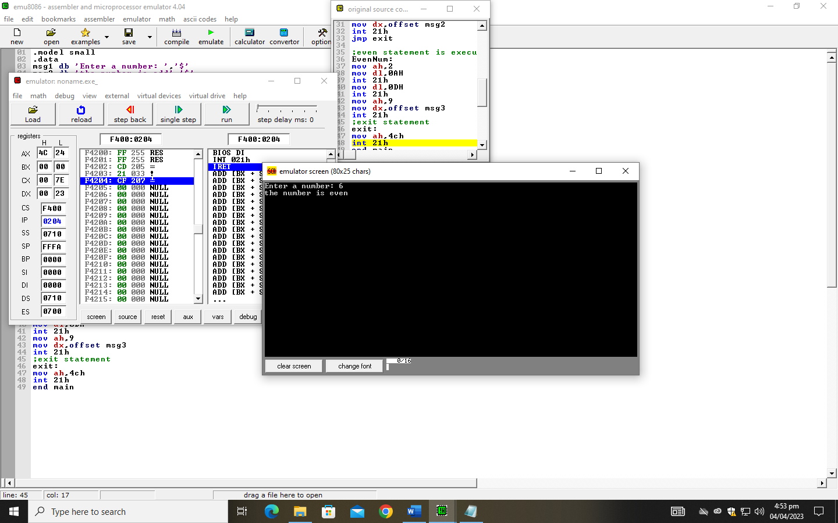

Task 02

.model small

.data

grade db 0

msg1 db ' Enter your marks: $'

msg2 db ' Not valid. $'

A db ' Your grade is A $'

B db ' Your grade is B $'

C db ' Your grade is C $'

D db ' Your grade is D $'

F db ' Your grade is F $'

.code

;moving data into special register

mov ax, @data

mov ds, ax

;printing string

mov ah, 09h

lea dx, msg1

int 21h

mov ah, 01h

int 21h

sub al, 30h

mov grade, al

;comparing the values

cmp grade, 8

jge L1

cmp grade, 6

jge L2

cmp grade, 4

jge L3

cmp grade, 2

jge L4

cmp grade, 0

jge L5

jmp not_correct

L1:

mov ah, 09h

lea dx, A

int 21h

jmp exit_p

L2:

mov ah, 09h

lea dx, B

int 21h

jmp exit_p

L3:

mov ah, 09h

lea dx, C

int 21h

jmp exit_p

L4:

mov ah, 09h

lea dx, D

int 21h

jmp exit_p

L5:

mov ah, 09h

lea dx, F

int 21h

jmp exit_p

not_correct:

mov ah, 09h

lea dx, msg2

int 21h

;exit statement for if one statement is executed or if not

exit_p:

mov ah, 4Ch

mov al, 0

int 21h

